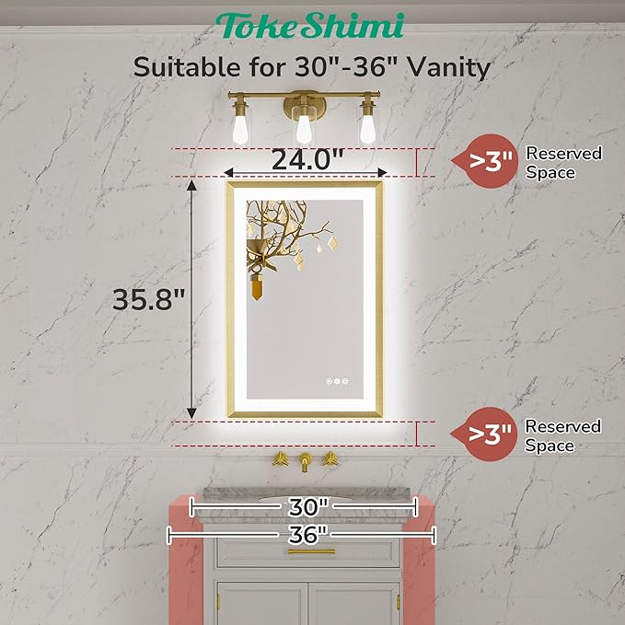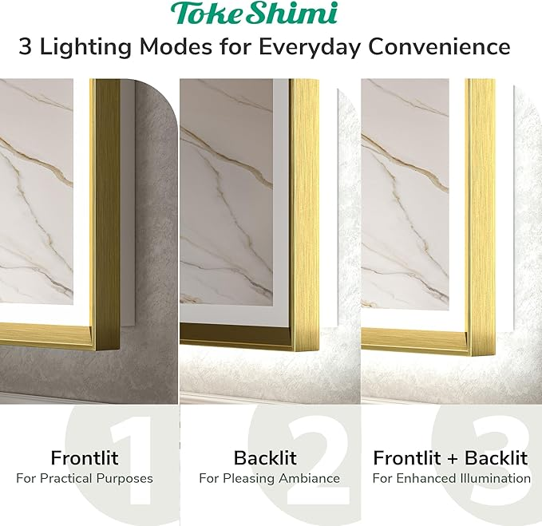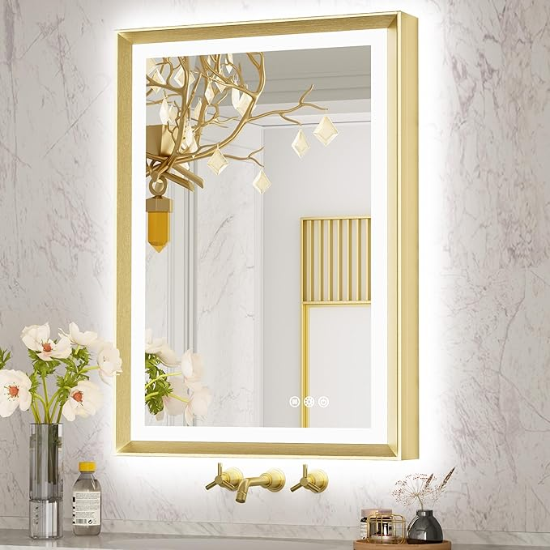

TokeShimi Gold 24x36 Inch LED Bathroom Vanity Mirror Frame Backlit and Front Lighted Aluminum Alloy Rectangle Beveled Edge Tricolors Stepless Dimmable Anti-Fog Memory Function for Wall Décor

**PRODUCT DESCRIPTION:**

|  |  |
| --- | --- |
| Brand | TokeShimi |
| Room Type | Bathroom, Living Room, Bedroom |
| Shape | Rectangular |
| Product Dimensions | 36"L x 24"W |
| Frame Material | Metal |

**About this item**

* 3 Independent Lightning Modes: With 2 LED Strips,TokeShimi LED Mirror provides 3 lightning modes for your specific needs: Front lit mode provides bright and direct lightning for makeup, shaving, or skincare. Backlit mode provides soft lighting that adds ambiance to the bathroom while reducing harsh shadows.Back+front lit mode is evenly lighted and brighter.
* Burshed Gold Aluminum Alloy Frame & Classy Beveled Edge Design: TokeShimi vanity mirror's anti-rust & stylish rectangular frame, offering crisp lines and a clean look,features with a sleek and modern design.TokeShimi beveled bathroom mirror adds a touch of elegance and sophistication to your bathroom decor and suits modern,farmhouse, industrial,contemporary, minimalist decor styles.
* Tricolors, Stepless Dimmable, Anti-Fog, Memory: TokeShimi Lighted bathroom mirror is controlled by 2 touch buttons: one for color temperature (3000K, 4000K, 6000K) and brightness level (10%~100%).Smart memory function stores the preferred lighting settings and anti-fog button provides a 5-minute heating and 1-hour auto cut-off function for safety and energy efficiency.
* Convenient French Cleat Installation: TokeShimi frame bathroom mirror is easy to install with a French Cleat hanger and can be powered by a plug or hard-wired to a wall switch. Support horizontally and vertically mounted.
* Sturdy Packaging with 3-Layers Foam & Impact-resistant Wooden Box: TokeShimi mirror with lights passed all rigorous drop and impact tests. Broken mirrors or missing mirror parts can be resolved by sending us some pictures. You don't need to worry about any inconvenience by broken mirror. Please feel free to contact us for any issues.